牙叔教程 简单易懂

**效果**

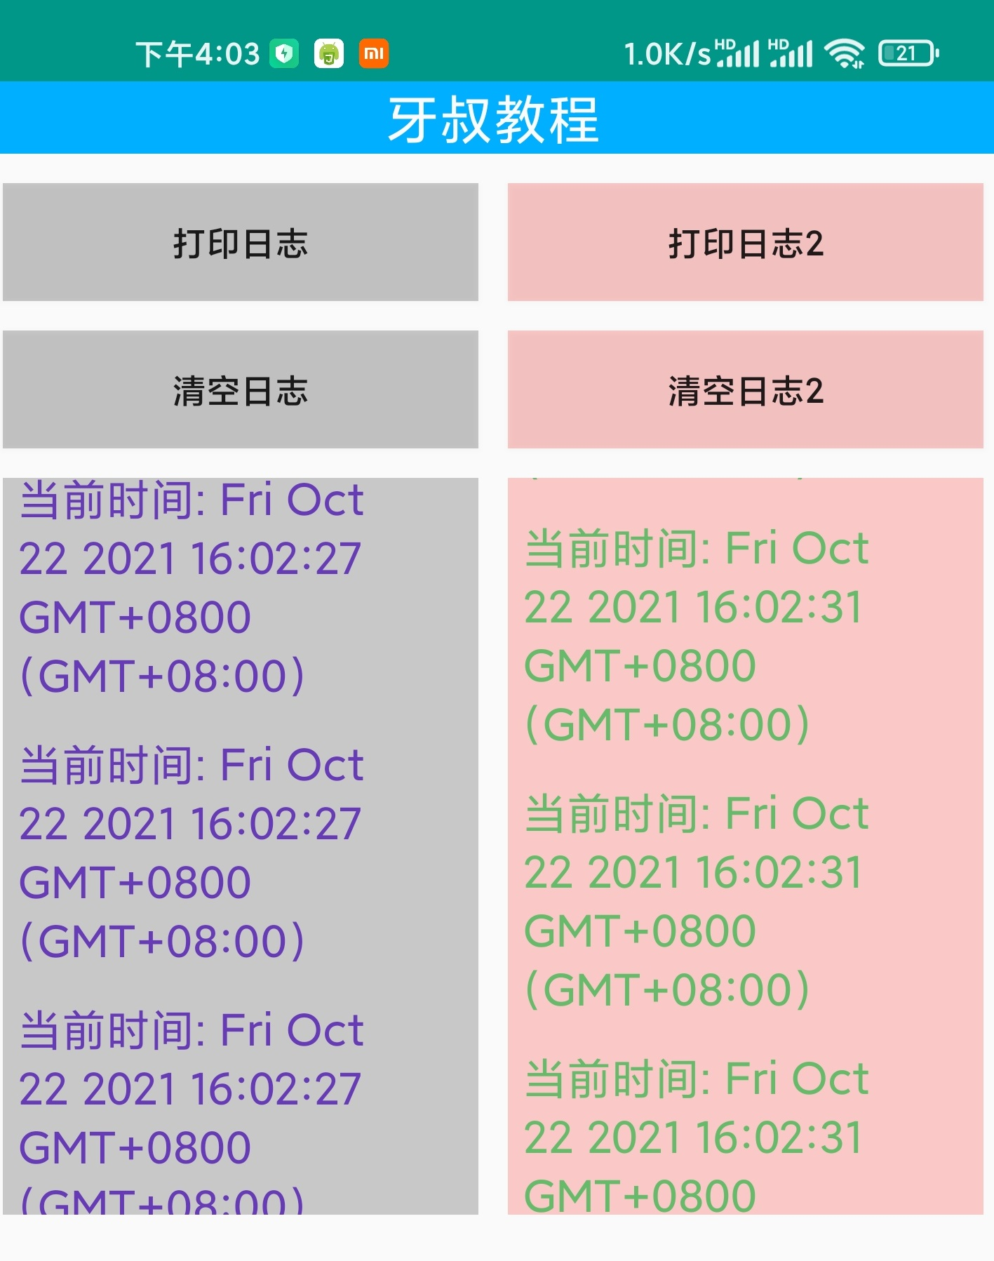

**环境**

手机: Mi 11 Pro

Android版本: 11

Autojs版本: 9.0.10

**名人名言**

思路是最重要的, 其他的百度, bing, stackoverflow, github, 安卓文档, autojs文档, 最后才是群里问问  
--- 牙叔教程

**声明**

部分内容来自网络  
本教程仅用于学习, 禁止用于其他用途

**bilibili**

[牙叔教程](https://space.bilibili.com/26079586)

**微信公众号 牙叔教程**



**QQ群**

747748653  


**源码**

"ui";

/*

* @version: 1.0

* @Date: 2021-10-22 11:28:54

* @LastEditTime: 2021-10-22 16:01:48

* @LastEditors: 牙叔

* @Description:

* @FilePath: \两个控制台\main.js

* @名人名言: 牙叔教程 简单易懂

* @bilibili: 牙叔教程

* @公众号: 牙叔教程

* @QQ群: 747748653

*/

engines.all().map((ScriptEngine) => {

if (engines.myEngine().toString() !== ScriptEngine.toString()) {

ScriptEngine.forceStop();

}

});

importClass(Packages.androidx.recyclerview.widget.RecyclerView);

importClass(Packages.androidx.recyclerview.widget.LinearLayoutManager);

importClass(android.graphics.drawable.BitmapDrawable);

importClass(Packages.androidx.recyclerview.widget.DividerItemDecoration);

importClass(android.graphics.BitmapFactory);

importClass(android.graphics.Paint);

importClass(android.graphics.Color);

importClass(android.widget.LinearLayout);

importClass(java.util.ArrayList);

/* -------------------------------------------------------------------------- */

ui.layout(

<vertical>

<text id="info" textSize="22sp" marginBottom="6" textColor="#fbfbfe" bg="#00afff" w="*" gravity="center">

牙叔教程

</text>

<horizontal>

<vertical layout_weight="1" layout_width="0dp">

<button id="btn" bg="#33000000" margin="6">

打印日志

</button>

<button id="clear" bg="#33000000" margin="6">

清空日志

</button>

<androidx.recyclerview.widget.RecyclerView id="rv" margin="6" bg="#33000000" w="*" h="300dp" />

</vertical>

<vertical layout_weight="1" layout_width="0dp">

<button id="btn2" margin="6" bg="#33ff0000">

打印日志2

</button>

<button id="clear2" margin="6" bg="#33ff0000">

清空日志2

</button>

<androidx.recyclerview.widget.RecyclerView id="rv2" margin="6" bg="#33ff0000" w="*" h="300dp" />

</vertical>

</horizontal>

</vertical>

);

let itemView = (

<TextView

id="content"

layout_width="match_parent"

layout_height="wrap_content"

textIsSelectable="true"

textSize="18sp"

textColor="#673ab7"

margin="6"

></TextView>

);

let itemView2 = (

<TextView

id="content"

layout_width="match_parent"

layout_height="wrap_content"

textIsSelectable="true"

textSize="18sp"

textColor="#66bb6a"

margin="6"

></TextView>

);

let layoutManager = new LinearLayoutManager(context);

ui.rv.setLayoutManager(layoutManager);

let mLogEntries = new ArrayList();

setRecyclerViewAdapter(ui.rv, itemView, mLogEntries);

/* -------------------------------------------------------------------------- */

let layoutManager2 = new LinearLayoutManager(context);

ui.rv2.setLayoutManager(layoutManager2);

let mLogEntries2 = new ArrayList();

setRecyclerViewAdapter(ui.rv2, itemView2, mLogEntries2);

/* -------------------------------------------------------------------------- */

ui.btn.click(function () {

let logEntry = {

content: "当前时间: " + new Date(),

};

mLogEntries.add(logEntry);

});

ui.clear.click(function () {

ui.post(function () {

mLogEntries.clear();

ui.rv.getAdapter().notifyDataSetChanged();

});

});

ui.btn2.click(function () {

let logEntry = {

content: "当前时间: " + new Date(),

};

mLogEntries2.add(logEntry);

});

ui.clear2.click(function () {

ui.post(function () {

mLogEntries2.clear();

ui.rv2.getAdapter().notifyDataSetChanged();

});

});

/* -------------------------------------------------------------------------- */

let lastCount = mLogEntries.size();

let lastCount2 = mLogEntries2.size();

setInterval(function () {

let currentCount = mLogEntries.size();

let currentCount2 = mLogEntries2.size();

if (lastCount < currentCount) {

refreshLog(lastCount, currentCount, mLogEntries, ui.rv);

}

if (lastCount2 < currentCount2) {

refreshLog(lastCount2, currentCount2, mLogEntries2, ui.rv2);

}

lastCount = currentCount;

lastCount2 = currentCount2;

}, 100);

/* -------------------------------------------------------------------------- */

function refreshLog(lastCount, currentCount, mLogEntries, rv) {

let size = mLogEntries.size();

if (size == 0) {

return;

}

let mLogListRecyclerView = rv;

mLogListRecyclerView.getAdapter().notifyItemRangeInserted(lastCount, currentCount - 1);

mLogListRecyclerView.scrollToPosition(size - 1);

// mLogListRecyclerView.getAdapter().notifyDataSetChanged();

}

function createAdapter(mLogEntries, itemView, rv) {

return RecyclerView.Adapter({

onCreateViewHolder: function (parent, viewType) {

// 视图创建

let view;

let holder;

view = ui.inflate(itemView, parent, false);

holder = JavaAdapter(RecyclerView.ViewHolder, {}, view);

return holder;

},

onBindViewHolder: function (holder, position) {

// 数据绑定

let logEntry = mLogEntries.get(position);

holder.itemView.setText(logEntry.content);

},

getItemCount: function () {

return mLogEntries.size();

},

});

}

function setRecyclerViewAdapter(recycleview, itemView, mLogEntries) {

let newAdapter = createAdapter(mLogEntries, itemView, recycleview);

recycleview.setAdapter(newAdapter);

}